**ActiZ translation**

Excl. Subtitling protagonist and clients

**Introduction screen**

You have the overview, you decide.

When it comes to geriatric care, there is often more to a situation. You have 3 minutes to find out what is really going on. Listen carefully to the story, observe and click around the room and prick up your ears.

**Please note:** even the smallest of things could be an important clue. Ask for a hint if you get stuck.

Good luck!

CONTINUE

**Introduction cases**

Mister Pinas:

Mister Pinas’ groceries

What a fridge can tell you

Mister Davids:

Having coffee with mister Davids

You’re not given a saucer

Family van Zand:

The family Van Zand’s household

A living room containing more than meets the eye

**Explanatory Screen**

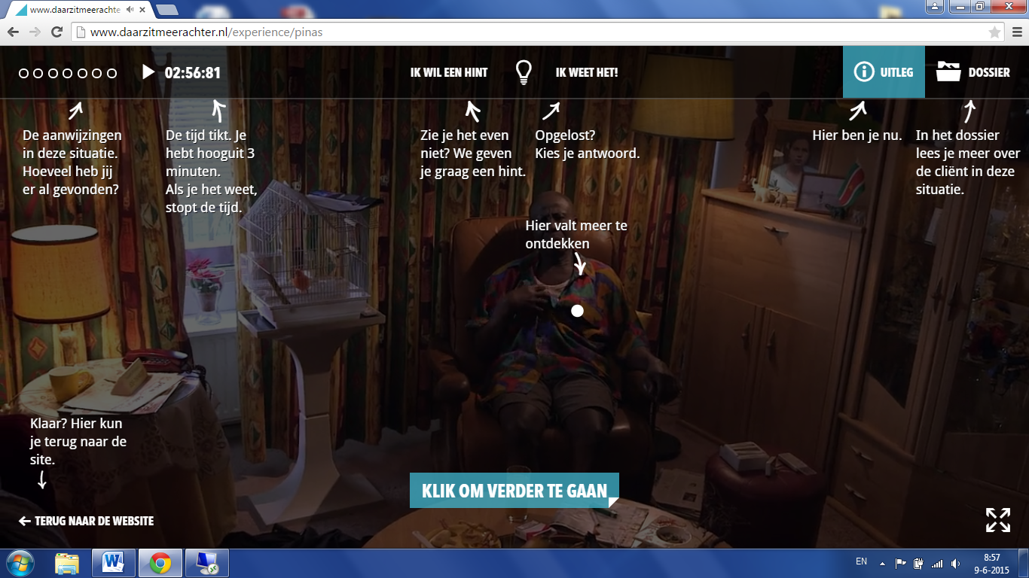

Top from left to right:

1 – Top left: The clues in this situation. How many have you found so far?

2 – 02:56:81: Time is ticking away. You have a maximum of 3 minutes. When you know, the clock stops.

3 – I NEED A HINT: Getting stuck? We’re happy to give you a hint.

4 – I KNOW: Solved it? Select your answer. (Centre screen) Find out more here.

5 – EXPLANATION: You’re here.

6 – FILE: Read more about the client in the file

7 – Clue point: Here is more to explore

Bottom Left Corner from top to bottom and then left to right:

1 – Ready? Here you can return to the site

(arrow down)

2 – BACK TO THE SITE (arrow pointing left)

3 – (Centre) CLICK HERE TO CONTINUE

CASE MISTER PINAS

**Video clues**

You have the overview, you decide. So this includes whether specialised care is required and who to approach for it.

Elderly people have a lot of life experience. They can often tell you the most beautiful stories.

**Notification in the case of not consulting the file**

Do you really know? There is no guessing in geriatric care and you can only decide after having consulted the file. Consult the file now.

**Questions and Answers**

1/3 What’s the first thing you do?

1. Notify the GP
2. Call the pharmacy
3. Win trust

Back to the situation

2/3 What’s wrong with mister Pinas?

1. His dementia has rapidly deteriorated. You call the GP.
2. He may be suffering from a delirium. You call the GP.
3. He’s suffering from side-effects of his medication. You contact the pharmacy.

3/3 What follow-up plan do you have?

1. Mister Pinas has lost his sense of time, you ask the neighbour to buy a clock.
2. After consulting the GP you have Mr Pinas admitted to hospital.
3. You draw up a care plan to monitor him over the next few days.

**Follow-up Plan**

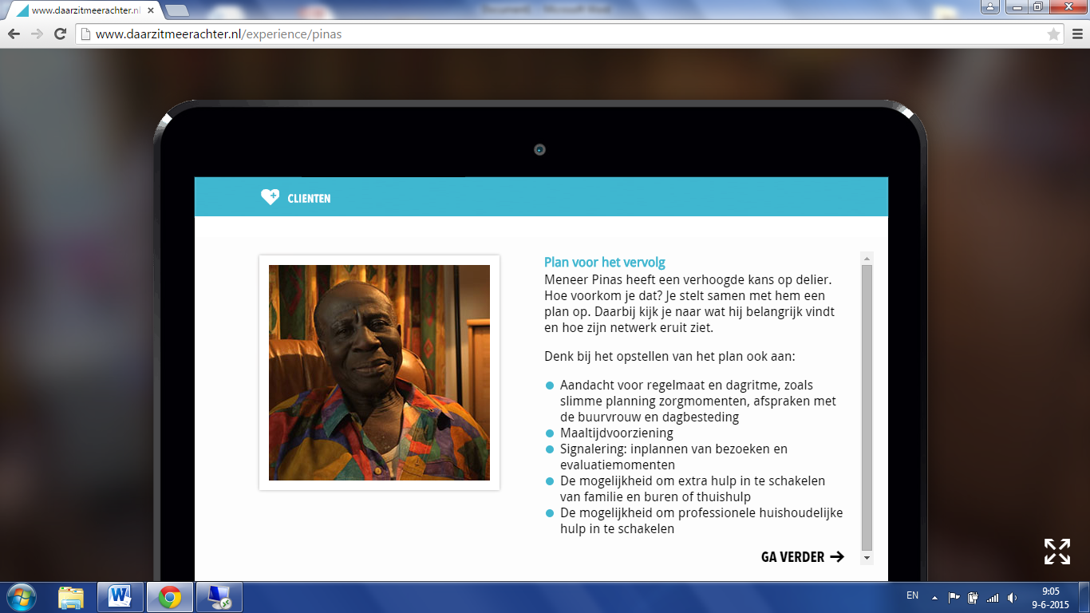

Screenshot translation:

Follow-up Plan

Mister Pinas has an increased risk of delirium.

How can you prevent this? Draw up a plan together with Mr Pinas.

Take into account what is important to him and find out more about his network.

Think of the following when drawing up the plan:

* Focus on regularity and daily rhythm such as clever planning of care moments, agreements with the neighbour and a day programme.
* Provision of meals.
* Alerts: planning of visits and evaluation moments.
* The possibility to request further help from family, neighbours or home assistance.
* The possibility to seek professional domestic assistance

**End**

Well done!

Your time: …

Clues: …

Share it and challenge others as well

Back to home

Back to cases

CASE MISTER DAVIDS

**File**

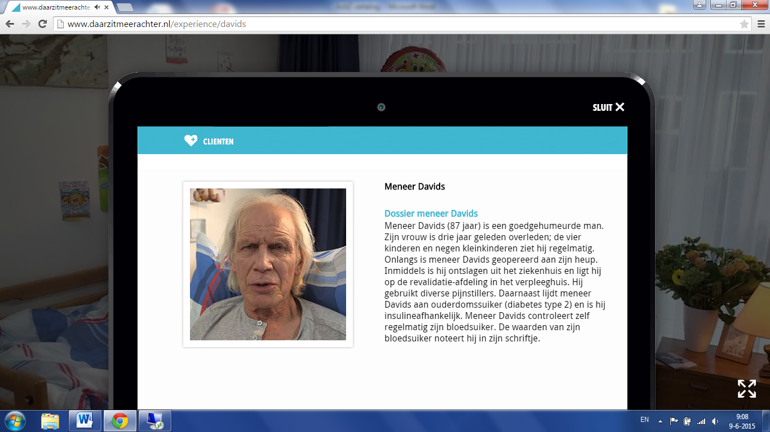

Screenshot translation:

Mister Davids

Mister Davids’ File

Mister Davids (87 years old) is a cheerful person. His wife passed away three years ago;

He frequently sees the four children and nine grandchildren. Mister Davids recently had hip surgery.

He has meanwhile been discharged from hospital and is convalescing in a nursing home. He’s on several sorts of painkillers. On top of this, Mr Davids has been diagnosed with age-related diabetes (diabetes type II) and he is dependent on insulin. Mr Davids regularly checks his blood sugar levels. He writes down the measurements in a diary.

**Video clues**

As a registered nurse you work together with GPs, specialists and the family.

You’re the linchpin between family, doctor and client. You listen, discuss and decide.

Diabetes diary (subtitles)

Blood glucose results (subtitles)

**Questions and answers**

1/3 What is behind all this?

1. Mister Davids’ painkillers are causing him discomfort.
2. Mister Davids is suffering from hypoglycaemia.
3. Mister Davids is hyperglycaemic.

2/3 What do you do now?

1. You give him dextrose or a sandwich and lemonade.
2. You give him a shot of insulin.
3. You give him more painkillers.

3/3 How can we prevent this from happening in the future?

1. Banning cakes from the ward.
2. Talk to mister Davids and observe with the main carer if he is still capable of measuring his blood sugar levels himself.
3. Have a serious talk with mister Davids and tell him to pay more attention.

**Follow-up Plan**

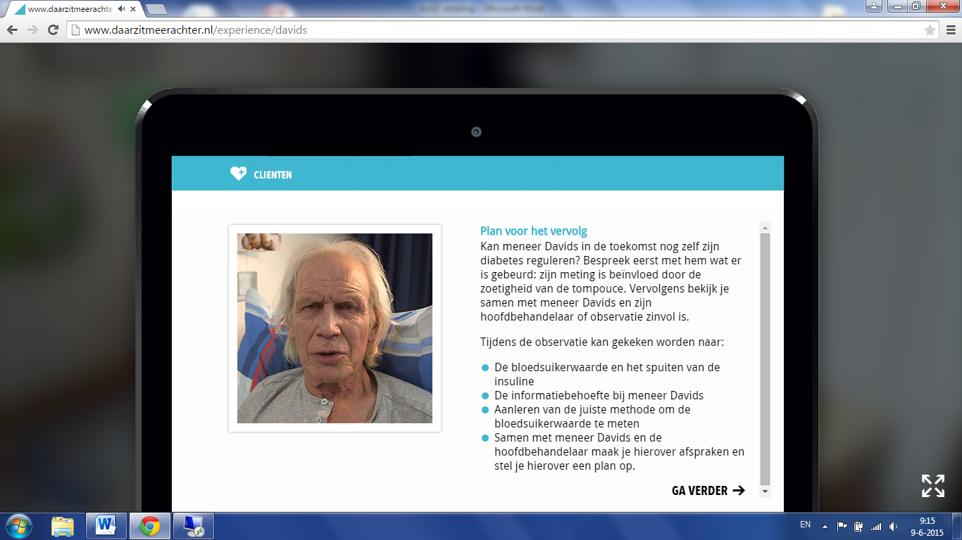

Screenshot translation:

Follow-up Plan

Will Mister Davids still be capable of controlling his diabetes by himself in the future? First, discuss with him what happened: his measurements were biased by the sugar inside the pudding cake. Then, together with mister Davids and his main carer, decide whether it would be useful to observe him.

During the observation you could focus on:

* Blood sugar levels and injecting insulin.
* Mister Davids’ information requirements.
* Giving instructions on measuring blood sugar levels correctly.
* Making agreements with mister Davids and the main carer and formulating them in a plan.

CASE FAMILY VAN ZAND

**File**

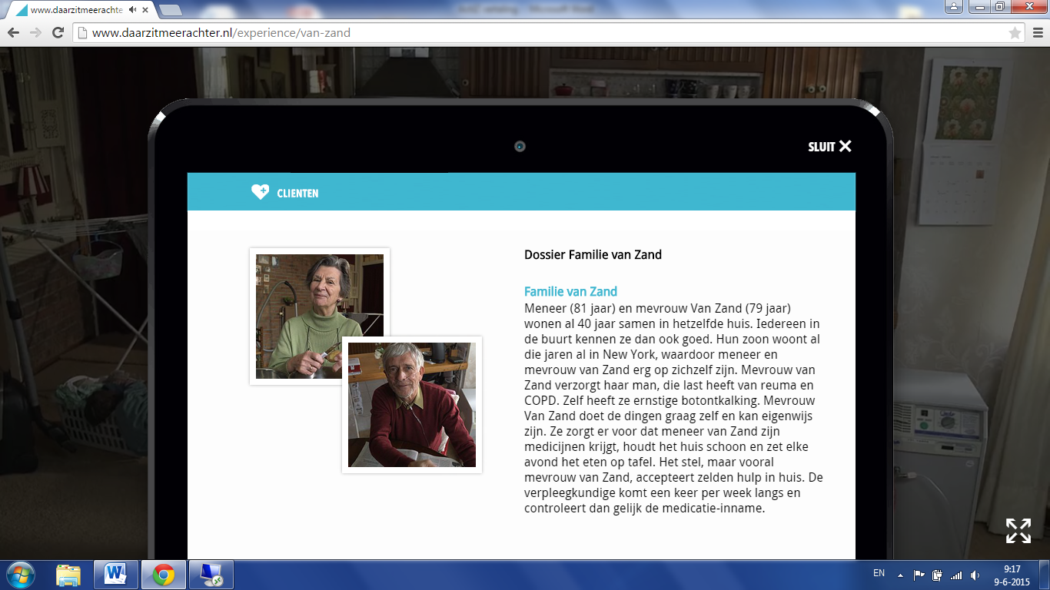

Screenshot translation

Family Van Zand file

Family Van Zand

Mr Van Zand (81 years old) and Mrs Van Zand (79 years old) have been living together in the same house for 40 years, so everybody in the neighbourhood knows them well. With their son living in New York for the same number of years, Mr and Mrs Van Zand have become quite self-sufficient. Mrs Van Zand takes care of her husband, who is suffering from rheumatism and COPD. Mrs Van Zand suffers from severe osteoporosis. Mrs Van Zand likes to do things herself and can be quite stubborn. She makes sure Mr Van Zand takes his medication, she does the housekeeping and cooks a meal every day. The couple, but mostly Mrs Van Zand, hardly ever accept any home assistance. The nursing officer visits once a week and checks whether the medication is being taken properly.

**Video clues**

A registered nurse’ work is varied. You’re not just the first point of contact but you’re also responsible for dressing wounds, for instance.

As a registered nurse you manage your own diary. You plan your own appointments with your clients.

Elderly people frequently have multiple conditions, which are often related to one another.

**Questions and answers**

1/3 What’s the first thing you do?

1. Make an appointment with the GP about Mr Van Zand's COPD in consultation with the couple.
2. Make an appointment with the GP about Mrs Van Zand’s painful arm in consultation with the couple.
3. Clear up the house.

2/3 What is the real problem?

1. Mr Van Zand’s COPD.
2. Mrs Van Zand’s osteoporosis.
3. Their capacity to live independently.

3/3 What is your long-term plan?

1. Sign up Mr Van Zand for a nursing home.
2. Forbid Mrs Van Zand to do the housekeeping.
3. Draw up a care plan and involve the appropriate healthcare professionals.

**Follow-up Plan**

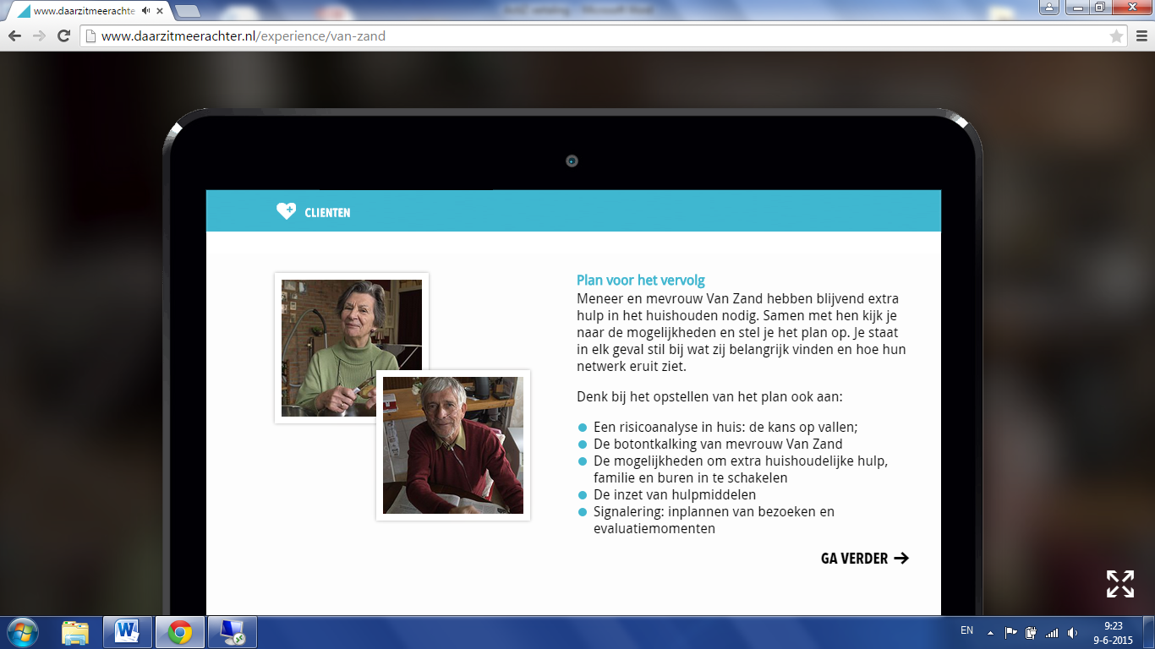

Screenshot translation

Follow-up Plan

Mr and Mrs Van Zand permanently need extra help in the home with the housekeeping. Discuss the various options with them and draw up a plan together. Whatever you do, take note of what they consider important and find out more about their network.

Bear the following in mind when drawing up a plan:

* A risk analysis of the home; risk of falling.
* Mrs Van Zand’s osteoporosis.
* The options for extra help with the housekeeping; involve family and neighbours.
* Make use of aids
* Monitoring: plan visits and evaluation moments.